**CSE 281: Data structures and Algorithms Lab**

**Lab Sheet 10**

**Graph Traversals**

*Instructions: Write java programs and algorithms for question 1 and question 2.*

*Reference to java API is available at :* [*http://192.168.0.48/javadocs/api/index.html*](http://192.168.0.48/javadocs/api/index.html)

1. Write the java code to represent a graph using adjacency matrix . The sample input and output are shown below.

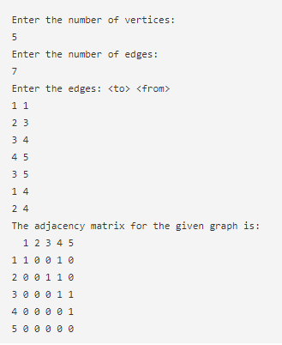

1. Implement BFS and DFS algorithm and test it in the sample graph discussed in class.

NB: Upload all lab sheets in aums. Format of the document to be uploaded is

Lab sheet question

Your code

Result screen shot